[**Responsive Header Menu – IA**](http://www.naturaltherapypages.com.au/)

First of all, when I landed and navigate thru this website my thoughts were about the overuse of text and heaps of data displayed. Probably a "less is more" design would be a great idea.

The header might be a bit confusing for some users as there are different search boxes and dropdown selectables, which can confuse some of the visitors. A review and redesign of the site will definitely improve the User Experience/User Interface (UI/UX).

The header is quite relevant / important in this website, but in my opinion exceeds in terms of average height compared to other related websites.

Hence, I would unify header-partners and header in one, and below, the black & blue header menu.

The blue submenu should always have the same height, regardless the current category.

In a first approach I would re-design a 6 elements menu as follow:

**Practitioners**

**Training**

**Products**

**Rooms/Jobs**

**Articles**

**Therapies**

In a second approach I will place **List of business** somewhere else in the content page as it is on the footer too. No need to keep in the header longer.

**Browse by Therapies** (desktop web) has too many items, I would rather change for **Therapies**.

Be aware of the limited height of the screen in mobile apps.

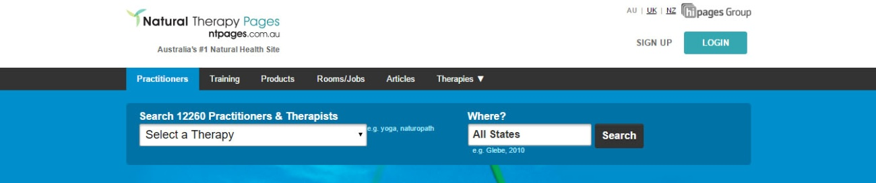

The following quick mockup can give you and idea of what I am thinking on **(desktop and wide screens):**

The following quick mockup can give you and idea of what I am thinking on (**mobiles and tablets small resolution**):

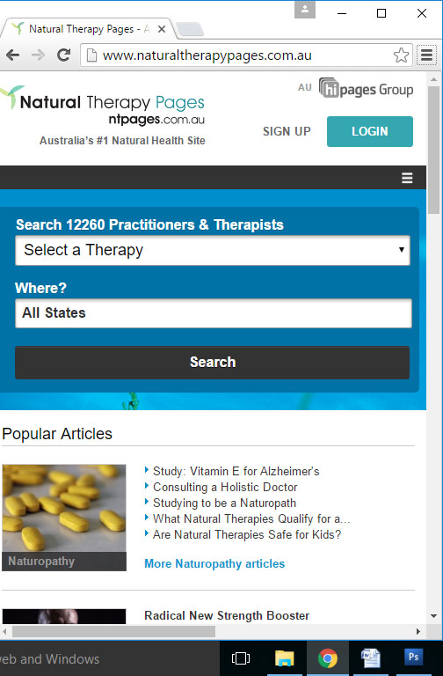

**Breakpoints**

As a Frontend Developer I always use the standard breakpoints provided by Bootstrap, which allows me to support a wide variety of screen resolutions.

The following media-queries are widely used so far:

/* Custom, iPhone Retina */

@media only screen and (min-width : 320px) { }

/* Extra Small Devices, Phones */

@media only screen and (min-width : 480px) { }

/* Small Devices, Tablets */

@media only screen and (min-width : 768px) { }

/* Medium Devices, Desktops */

@media only screen and (min-width : 992px) { }

/* Large Devices, Wide Screens */

@media only screen and (min-width : 1200px) { }

/*========== Non-Mobile First Method ==========*/

/* Large Devices, Wide Screens */

@media only screen and (max-width : 1200px) { }

/* Medium Devices, Desktops */

@media only screen and (max-width : 992px) { }

/* Small Devices, Tablets */

@media only screen and (max-width : 768px) { }

/* Extra Small Devices, Phones */

@media only screen and (max-width : 480px) { }

/* Custom, iPhone Retina */

@media only screen and (max-width : 320px) { }